Assignment 11: Expedition Proposal

Guidelines
- Write a one page essay in MS Word and answer the questions below.
- Your papers must be submitted in MLA format.
- Submit your .doc or .docx files below.

Description
It is the late fifteenth century, Constantinople has fallen to the Ottoman Turks and advances in navigation and ship-building have opened up many opportunities for commerce, conquest, and colonization. Imagine you are an intrepid ship-captain, you have many leather bound atlases and your ship-cabin smells of rich mahogany. (Fun Fact: Mahogany is actually indigenous to the America's) You have decided to launch your own voyage but don't have the funds to do so. For this assignment you will be writing a short proposal to a European Monarch to convince them to bankroll your expedition. Your proposal should be in essay format and no longer than 1 page. (Kings are busy after all)
Your proposal should include at least 3 arguments based in historical fact or context. For example: Columbus gained the support of the Spanish Monarchs by convincing them that a route West would help them compete with the growing influence of Portuguese explorers. You do not need to consult any sources other than the textbook/video resources but you may if you wish. Creativity is encouraged but not required.
Some things you may want to include:
- The Monarch or Country you are addressing.
- Your proposed destination and the year you intend to sail.
- What you hope to find at your destination.
- Why your voyage will benefit the Monarch.
- Flattery.

Assignment 12: M12. Assignment
No unread replies.No replies.

Renaissance Biography

Guidelines
- Following the instructions below, you will post your response in the discussion area accompanying this assignment.
- Your post should be two to three paragraphs long, and follow the Discussion Post rubric.
- Respond to one of your classmate's posts.

Description
The intellectual and artistic achievements of the Renaissance were made possible by the many great people who lived at this time and are still commonly known today. Understanding their lives can give tremendous insight into the history and society of the time they lived through. For your assignment choose a figure from the Renaissance that you believe was influential or important and write a brief biography consisting of two to three paragraphs, then respond to one classmate. You are not limited to those listed below.
To find information, use the OCC Library databases "Ancient and Medieval History Online", "Modern World History Online", or "Oxford Reference Collection." All three will provide a short synopsis of your subject and get you familiar with some of the History resources available to you. At the end of your biography cite your source(s) in MLA format and post the biography below.
NOTE: The databases can be accessed from home through Ocean Connect and are available to all OCC students. Click on Library Services and scroll through the Alphabetical List.
NOTE: "Ancient and Medieval History Online" and "Modern World History Online" can be found in the "Facts on File" collection of databases.
NOTE: "Ancient and Medieval History Online" and "Modern World History Online" have a "Citation" button on each article that will provide the MLA format. For additional citation information consult the "Citation Resources" link on the Library Services page.
- Boccaccio
- Lucrezia Borgia
- Botticelli
- Brunelleschi
- Charles V, Holy Roman Emperor
- Isabella d'Este
- Leonardo da Vinci
- Donatello
- Francesco Fosari
- Ghiberti
- Giotto
- Johann Gutenberg
- Niccolo Machiavelli
- Masaccio
- Cosimo de Medici
- Lorenzo de Medici
- Michaelangelo
- Francesco Petrarch
- Pico
- Pope Alexander VI
- Pope Clement VII
- Pope Julius II
- Pope Leo X
- Pope Nicholas V
- Pope Sixtus IV
- Raphael
- Girolamo Savonarola
- Ludovico Sforza
- Titian

Assignment 13: Art and the Reformation

Guidelines
- For this assignment you will read the descriptions below that articulate some of the characteristics of Reformation and Counter-Reformation Art.
- Then, examine the artwork below and determine which of the two styles it best represents, and which elements can be found, and why you think it belongs to that style. You may consult outside sources if you wish. No more than one paragraph is needed for each image.
- Submit your .doc or .docx files below.

Description
The years of the Reformation had a profound impact on the arts and artists. Some artists found a loss of patrons due to their reformist religious sympathies while others were forced to flee their homes as regions became divided between Catholic and Protestant. Art became a part of the battlefield and propaganda as some Protestant movements resorted to iconoclasm (the smashing of religious images) to rid churches of what they considered idols. The themes of Protestant art changed and became distinct, particularly in the Netherlands, and art itself was used to gain converts and as propaganda. The Catholic church convened the Council of Trent and one of the elements to emerge from it was a uniquely Catholic 'Counter-Reformation' art style that supported it's canons and was distinct from Protestant Art.
Note: Due to different patrons, time periods, artistic styles, not every piece of art will include every element or characteristic but the works of art chosen are considered strong examples of one "religious" style.

Some Characteristics of Reformation Art:
- Reduced focus on religious elements, which are considered idolatrous (There were some exceptions).
- Subjects such as portraiture, landscapes, still life, depiction of human weakness.
- Importance of the Bible.
- Salvation through faith alone rather than saints, clergy, angels, etc. (in works with religious elements).
- Common people as subject and everyday scenes.
- "Mysteries of the Faith" were downplayed: The Annunciation of Mary, Immaculate Conception, and Transfiguration.
- Transubstantiation (bread and wine transformed into body and blood) and Eucharist are avoided.
- Avoidance of large scenes, saints, popes, and clergy.
- Realism shows events without embellishments.
- Common use of engravings and woodcuts.

Some Characteristics of Counter Reformation Art:
- Distinctive aspects of Catholic dogma such as: The Immaculate Conception, Annunciation, and Transfiguration.
- Portrayal of Christ on the Cross, specifically to illustrate the Transubstantiation and importance of the Eucharist.
- Roles of Mary, the Saints, and Sacraments (Specifically the Eucharist/Transubstantiation) are important.
- Biblical painting is clear, direct, and compelling.
- Art should encourage piety by showing scenes of spiritual intensity.
- Art should be understandable to ordinary people.
- Salvation through good acts.

Image 1: The Last Supper - Tintoretto
An oil painting on canvas from 1592-1594 by Italian Artist Jacopo Tintoretto. In this work Jesus mingles with the apostles and the supernatural angels are lit by the light from his halo. The apostles are also depicted with halos and given distinction. Jesus is shown offering bread to one of the apostles in the manner of a priest and the angels signify the religious nature of this gesture.
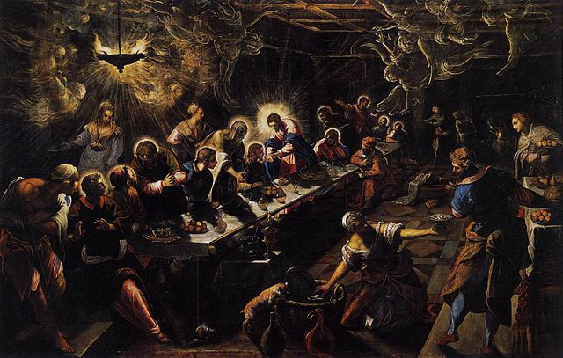
Source: "Jacopo Tintoretto - The Last Supper - WGA22649" by Tintoretto - Web Gallery of Art: Image Info about artwork. Licensed under Public Domain via Commons - https://commons.wikimedia.org/wiki/File:Jacopo_Tintoretto_-_The_Last_Supper_-_WGA22649.jpg#/media/File:Jacopo_Tintoretto_-_The_Last_Supper_-_WGA22649.jpg

Image 2: The Seven Works of Mercy - Caravaggio
An oil Painting circa 1607 by the Italian painter Carvaggio. This painting depicts the "Seven Corporal Works of Mercy", compassionate acts that all believers are expected to perform and lead to salvation. The acts depicted are: Bury the Dead, Feed the Hungry, Shelter the Homeless, Clothe the Naked, Visit the Sick, and Refresh the Thirsty.
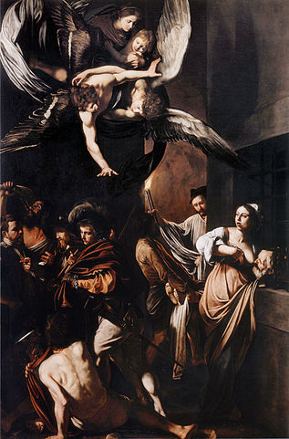
Source: "Caravaggio - Sette opere di Misericordia" by Caravaggio - Unknown. Licensed under Public Domain via Commons - https://commons.wikimedia.org/wiki/File:Caravaggio_-_Sette_opere_di_Misericordia.jpg#/media/File:Caravaggio_-_Sette_opere_di_Misericordia.jpg

Image 3: The Peasant Wedding - Pieter Bruegel the Elder
A 1567 genre painting by Flemish painter Pieter Bruegel. One of the most famous illustrations of Flemish peasant life, it has moralistic overtones such as the focus of the subjects on food and drink (gluttony and self-indulgence) and a lack of reverence for the spiritual nature of the occasion.
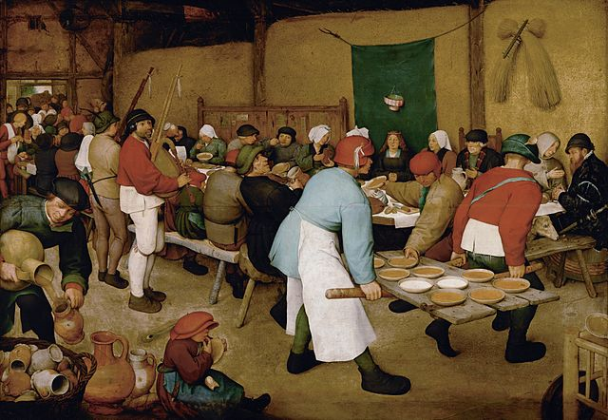
Source: "Pieter Bruegel the Elder - Peasant Wedding - Google Art Project 2" by Pieter Brueghel the Elder (1526/1530–1569) - Google Art Project: Home – pic Maximum resolution.. Licensed under Public Domain via Commons - https://commons.wikimedia.org/wiki/File:Pieter_Bruegel_the_Elder_-_Peasant_Wedding_-_Google_Art_Project_2.jpg#/media/File:Pieter_Bruegel_the_Elder_-_Peasant_Wedding_-_Google_Art_Project_2.jpg

Image 4: Law and Grace - Lucas Cranach the Elder
A woodcut by Lucas Cranach the Elder that is divided into two parts, Law and Gospel. On the left, Law, a demon and skeleton force a nude man into hell as Moses and the prophets point to the tablets of law. Christ sits in judgement above Adam and Eve. The motifs associate law with death and damnation. On the right, Gospel, the nude man is shown to Jesus by John the Baptist and Jesus does not sit in judgement of the man's good deeds, but instead offers salvation through mercy.
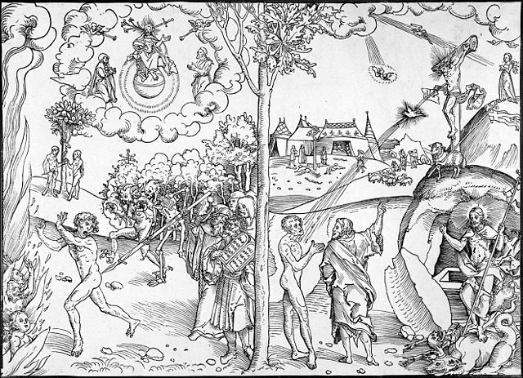
Source: "Cranach law and grace woodcut" by Lucas Cranach der Ältere 1529/30 (picture), user:Concord (scan) - http://faculty.wartburg.edu/wilson/arthistory/images/23/23-01.jpg. Licensed under Public Domain via Commons - https://commons.wikimedia.org/wiki/File:Cranach_law_and_grace_woodcut.jpg#/media/File:Cranach_law_and_grace_woodcut.jpg

Assignment 14: The Thirty Years' War

Guidelines
- Using MS Word, answer the questions below.
- Submit your .doc or .docx files below.

Description
Answer the questions below by consulting the maps and images included in this assignment.
- What regions did the House of Habsburg control at the abdication of Charles V?
- What were the dominant religions in Central Europe in 1560?
- Where were each of these religions most prominent?
- What Countries or States had a Protestant majority during the Thirty Years War?
- What region saw most of the military campaigns during the Thirty Years War?
- Which countries or states led those campaigns?
- Where were the two branches of the House of Habsburg based?
- How had the political boundaries of Central Europe changed by the end of the war in 1648?
- What states supported the Emperor during the Thirty Years' War? Which states opposed?
- How had the Habsburg domains changed from the reign of Charles V to 1700?

Image 1: House of Habsburg Dominions
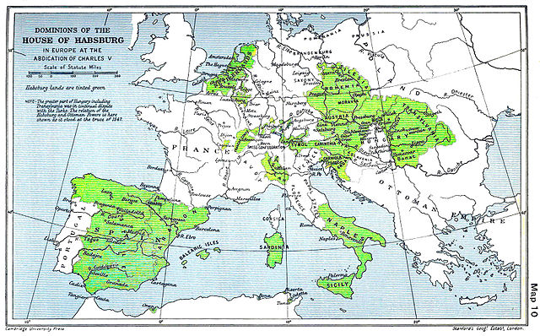
Source: "Habsburg Map 1547" by edited by Sir Adolphus William Ward, G.W. Prothero, Sir Stanley Mordaunt Leathes - The Cambridge Modern History Atlas, edited by Sir Adolphus William Ward, G.W. Prothero, Sir Stanley Mordaunt Leathes, and E.A. Benians. Cambridge University Press: London, 1912.Editors were Sir Adolphus William Ward (†1924), G.W. Prothero (†1922), and Sir Stanley Mordaunt Leathes (†1938). Individual authors of works making up the atlas are not identified, nor are the likely to be, after reasonable research.. Licensed under Public Domain via Wikimedia Commons - https://commons.wikimedia.org/wiki/File:Habsburg_Map_1547.jpg#/media/File:Habsburg_Map_1547.jpg (Links to an external site.)Links to an external site.

Image 2 : Religions in 1560
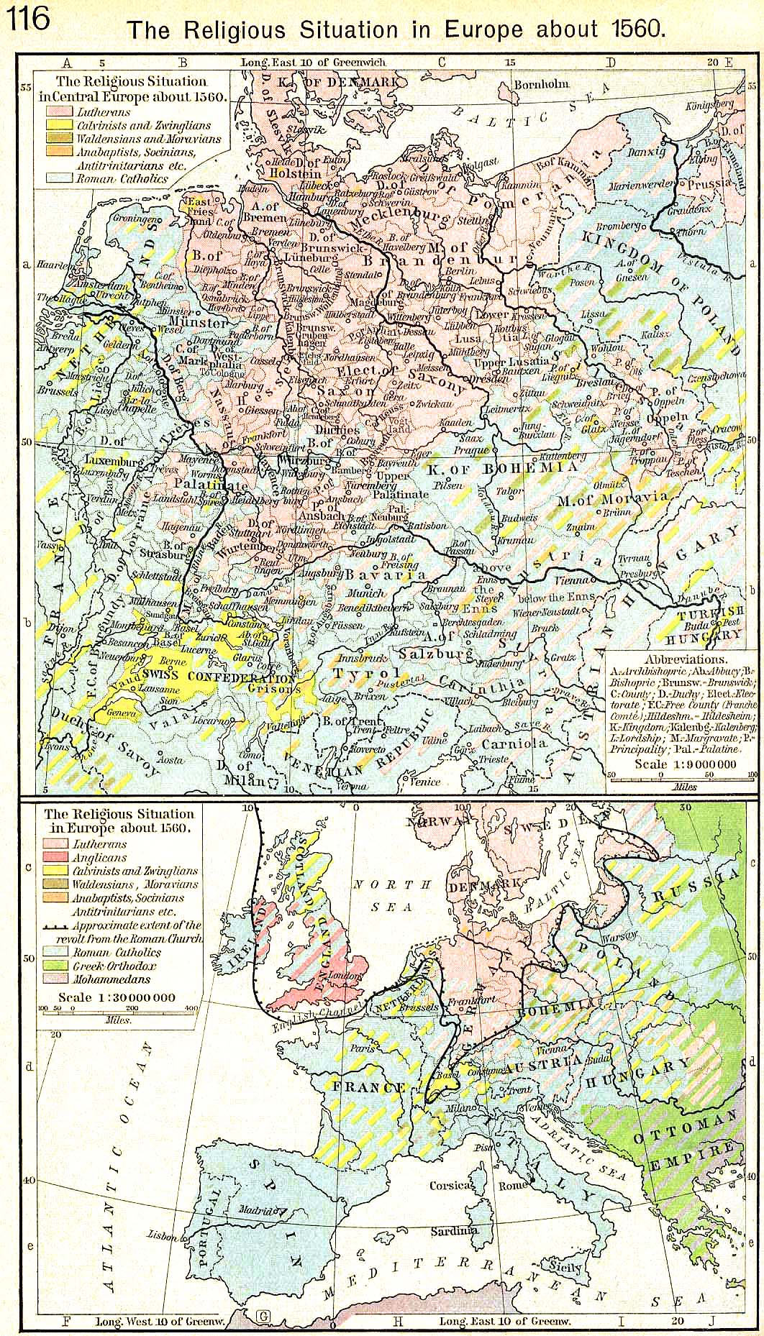
Source: "Europe religions 1560" by William R. Shepherd (died 1934) [3] - The Historical Atlas by William R. Shepherd, 1923. Downloaded from [1] at [2]. Licensed under Public Domain via Wikimedia Commons - https://commons.wikimedia.org/wiki/File:Europe_religions_1560.jpg#/media/File:Europe_religions_1560.jpg (Links to an external site.)Links to an external site.

Image 3: Thirty Years War Campaigns
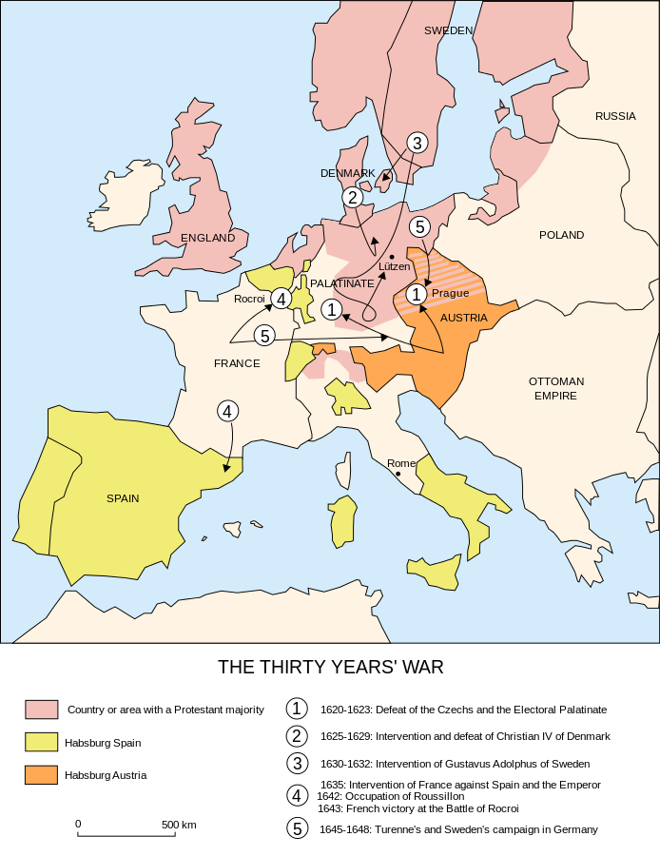
Source: "Map Thirty Years War-en" by Map_Thirty_Years_War-fr.svg: historicairderivative work: P. S. Burton (talk) - Map_Thirty_Years_War-fr.svg. Licensed under CC BY-SA 3.0 via Commons - https://commons.wikimedia.org/wiki/File:Map_Thirty_Years_War-en.svg#/media/File:Map_Thirty_Years_War-en.svg (Links to an external site.)Links to an external site.

Image 4: Europe in 1648
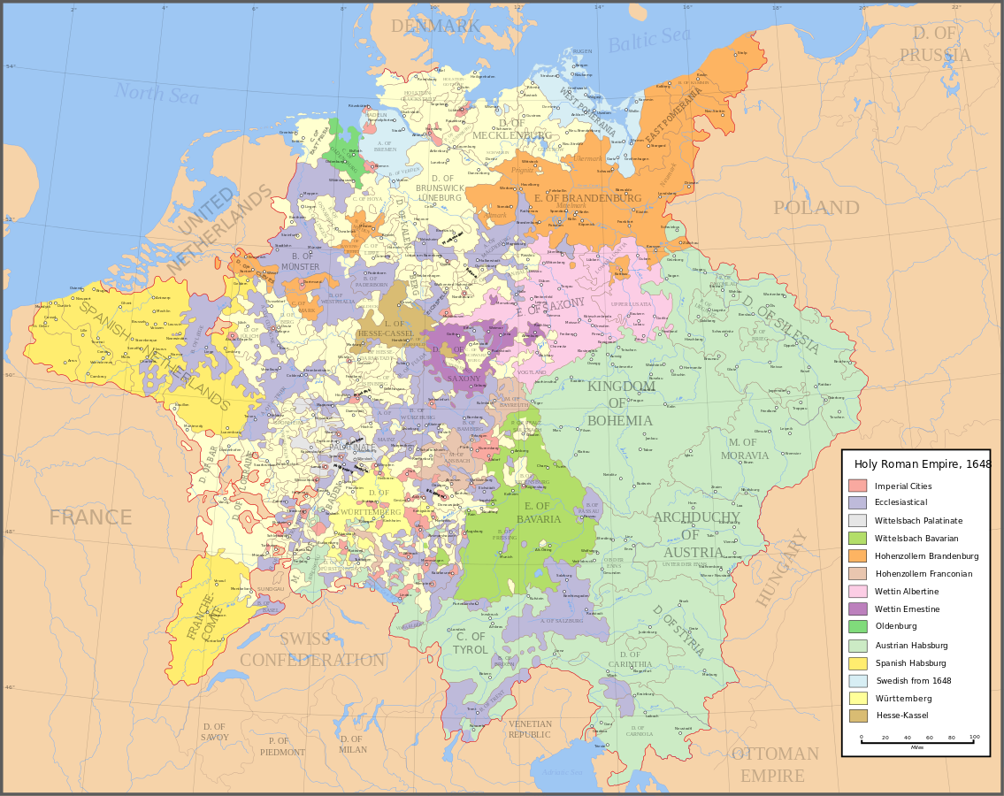
Source: "Holy Roman Empire 1648" by Astrokey44 - Made from the public domain map "Central Europe about 1648" from the Historical Atlas by William R. Shepherd, at the Perry-Castañeda Library Map Collection at the University of Texas. Further information from Overy, Richard, 2006, The Times Complete history of the world Times Books ISBN 0007181299, and from this mapSee also other maps at external links:Central Europe 1648Map on personal site, Europe in 1648Treaty of Westphalia1648 map of PrussiaBritannica, Spanish domains in 1648This vector image was created with Inkscape.. Licensed under CC BY-SA 3.0 via Commons - https://commons.wikimedia.org/wiki/File:Holy_Roman_Empire_1648.svg#/media/File:Holy_Roman_Empire_1648.svg

Image 5: State Involvement in Thirty Years' War

Directly against Emperor
Indirectly against Emperor
Directly for Emperor
Indirectly for Emperor
Source: "Thirty Years War involvement graph" by Thirty_Years_War_involvement.png: Foxhunt kingderivative work: Grandiose (talk) - Thirty_Years_War_involvement.png. Licensed under Public Domain via Commons - https://commons.wikimedia.org/wiki/File:Thirty_Years_War_involvement_graph.svg#/media/File:Thirty_Years_War_involvement_graph.svg

Image 6: Habsburg Domains 1700
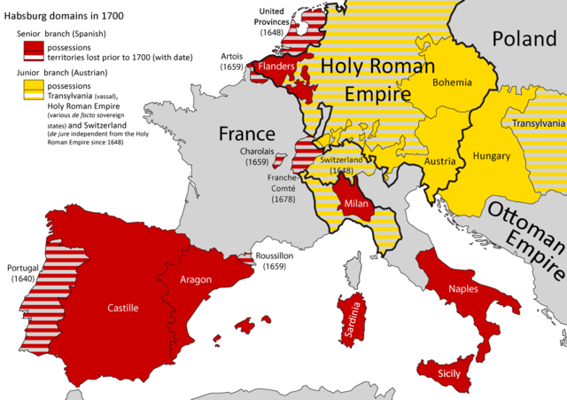
Source: "Habsburg dominions 1700" by Habsbourg-1700.png: Katepanomegasderivative work: Alphathon - This file was derived from: Habsbourg-1700.png:. Licensed under CC BY-SA 3.0 via Commons - https://commons.wikimedia.org/wiki/File:Habsburg_dominions_1700.png#/media/File:Habsburg_dominions_1700.png
\\

